# How to Create the Demo Azure Data Factory Using the ARM Template

* Before importing the ARM template, you will need an Azure SQL Server database
  + You can create the one from the demo by following the instructions in “Create Demo Database.docx”
* Create a new Azure Data Factory
* If you don’t already have arm_template.zip for the demo
  + Download Master branch located at <https://github.com/DataJoy-VJK/CharlieAndTheDataFactoryVJK/tree/master>
  + Extract files from CharlieAndTheDataFactoryVJK-master.zip
  + Navigate to CharlieAndTheDataFactoryVJK-master files
  + Extract arm_template.zip
* Open your new ADF (Author & Monitor)
* Go to the Author tab
* Click the “ARM template” dropdown and select “Import ARM template”

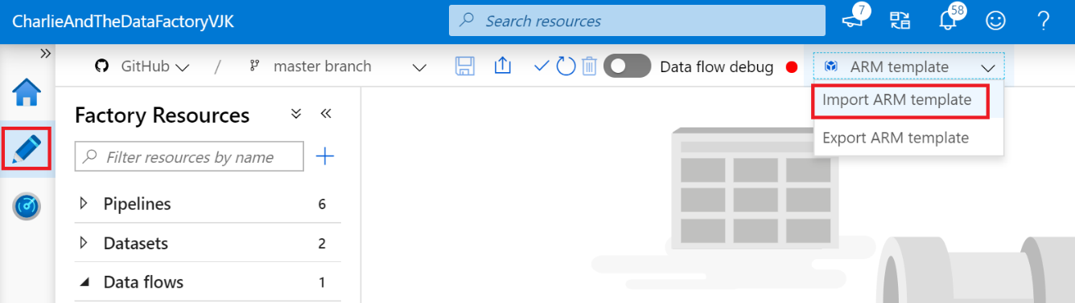

* Click “Build your own template in the editor”

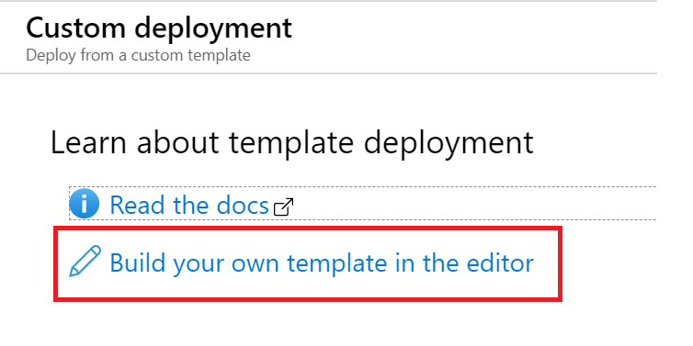

* Click “Load file”

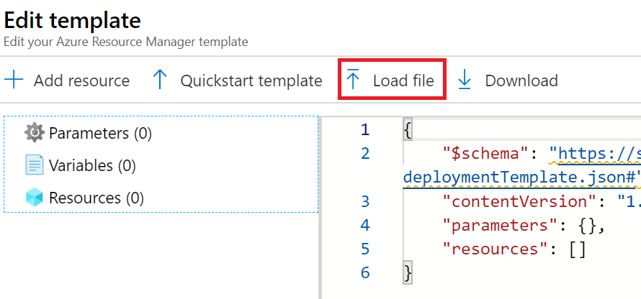

* Browse to where you extracted the arm-template files
* Select ARMTemplateForFactory.json under CharlieAndTheDataFactory-adf_publish > CharlieAndTheDataFactoryVJK

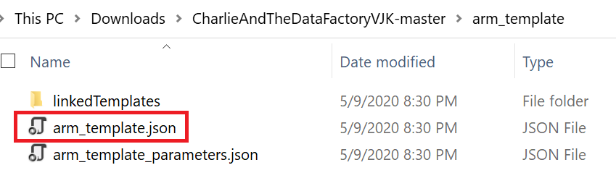

* Click Save
* On the “Custom Deployment” screen, select your subscription and resource group.
* Update “Factory Name” to your ADF name
* In “Ls_Azure SQL Charlie_Connection string”, enter the connection string for you Azure SQL Database
  + For example “integrated security=False;encrypt=True;connection timeout=30;data source={yourSQLserver}.database.windows.net;initial catalog={yourDB};user id={user id}”

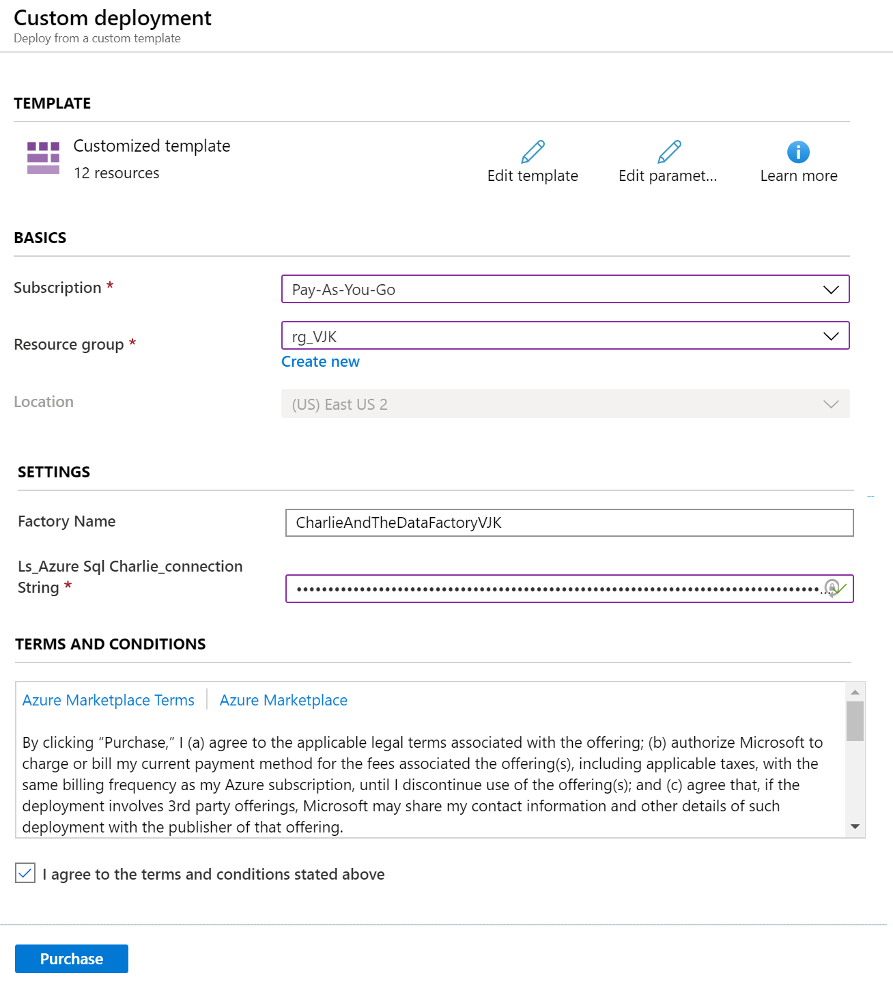

* Agree to the terms and click “Purchase”
* Go to back to your new ADF and Refresh
* Update passwords for Linked Services